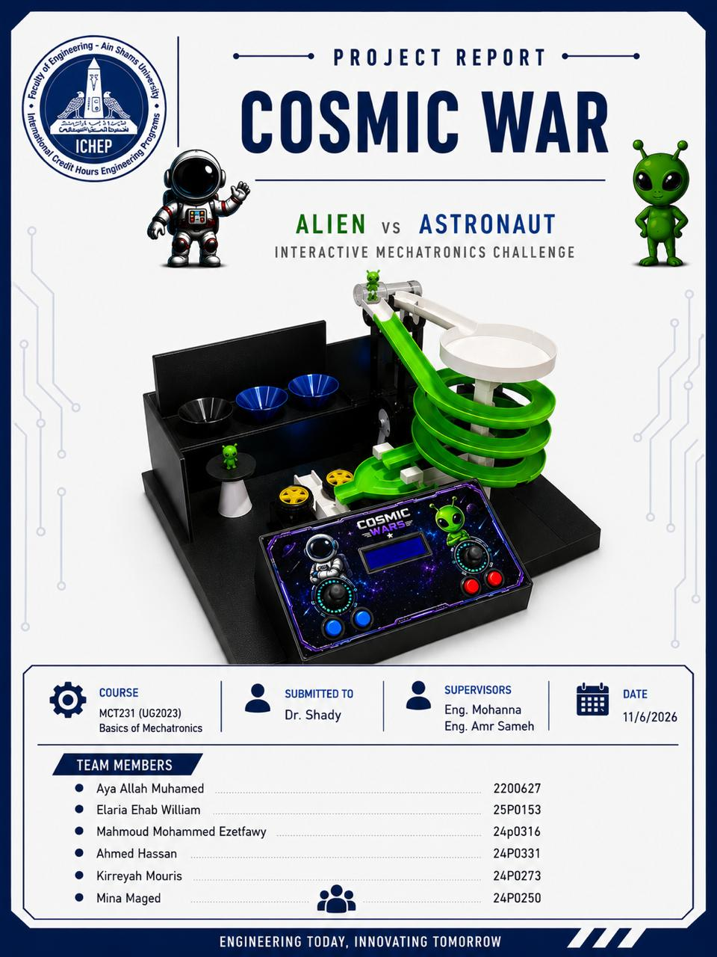
Contribution Table
Ahmed Hassan Abdel Aziz | 24P0311 | Code Sorting with lifting-Cad Design-wiring
Kireyah Mouris Mosaad | 24P0273 | Lifting and sorting hardware-presentation -Cad design-wiring
Elaria Ehab William | 25P0153 | Integrated Code – wiring – Cad design
Mahmoud Mohammed elzeftawy | 24P0316 | Wiring – Cad design-Github-Code shooting
Mina maged | 24P0250 | Integration Hardware -Report -Cad design
Aya Allah Mohamed | 2200627 | A0 poster -App -Decoration project

Design and Implementation of "Cosmios" – A Competitive Electromechanical Closed-Loop Game System
Institution: Ain Shams University, Faculty of Engineering
Program: Basic of mechatronics
Abstract
This report details the comprehensive design, conceptual physics modeling, and physical implementation of "Cosmios," a two-player competitive electromechanical game system. The project integrates three primary automated mechatronic subsystems—optical sorting, pneumatic transport, and kinetic projectile launch—into a continuous, self-sustaining loop. System operation is governed by a central microcontroller interfaced with a custom Human-Machine Interface (HMI) control panel. Utilizing a combination of optical sensory input, fluid dynamics, and motorized actuation, the system processes 5g projectiles, elevates them to a staging deck, and allows players to engage targets. This report outlines the system architecture, hardware infrastructure, closed-loop control logic, and measures taken to ensure system robustness and fault tolerance.
1. Introduction
1.1 Project Objectives
The primary objective of this project was to engineer "Cosmios," a fully functional, competitive mechatronics system that operates reliably with minimal manual intervention. The specific goals included:
- Designing a highly accurate optical sorting mechanism to distribute ammunition to respective players.
- Implementing a pneumatic elevator capable of consistently overcoming gravity to transport projectiles vertically.
- Engineering a high-velocity, dual-motor flywheel shooting mechanism actuated via precise player input.
- Developing a responsive HMI control panel to facilitate competitive gameplay while displaying real-time system telemetry.
1.2 Scope of Work
The scope encompasses the full spectrum of mechatronics system design: mechanical tolerancing, structural fabrication, isolated power circuit design, microcontroller state-machine programming, and the dynamic tuning of motorized actuators to ensure consistent performance under load.
2. Theoretical Background and Physical Principles
To guarantee the reliability of the physical mechanisms, core principles of dynamics and fluid mechanics were applied to the system's active stages.
2.1 Kinetic Launch Dynamics
The shooting mechanism relies on the efficient transfer of rotational kinetic energy. Two high-RPM DC motors, generating a steady-state torque of 1.8 kgf.cm, transfer energy into the linear kinetic energy of the 5g spherical projectile through mechanical friction. Assuming a secure grip with negligible slippage between the friction wheels and the projectile, the initial launch velocity is directly proportional to the angular velocity of the motors and the outer radius of the wheels.
Once ejected, the projectile's flight path is governed by parabolic motion. The consistency of the trajectory toward the physical targets is maintained by ensuring the DC motors do not stall or drop below their nominal RPM during the energy transfer phase, which requires adequate torque and current delivery.
2.2 Pneumatic Transport Principles
The lifting mechanism utilizes fluid dynamics to transport the projectile vertically against gravity. For the 5g ball to ascend reliably, the upward aerodynamic drag force generated by the airflow must strictly exceed the downward gravitational force. By ensuring that the 12V centrifugal blower delivers a high static pressure and maintaining tight mechanical tolerances within the acrylic tube to minimize air bypass, the upward pneumatic force consistently overcomes the ball's weight, resulting in smooth levitation.
3. System Architecture and Detailed Design
The Cosmios architecture employs a modular design, isolating subsystems to enhance fault tolerance and simplify maintenance.
3.1 Human-Machine Interface (HMI Control Panel)
The control panel is the operational command center, translating human inputs into electromechanical actuation with negligible latency.
- Analog Joysticks: Map player hand movements to dynamic system variables, allowing for strategic control.
- Tactile Push Buttons: Send hardware interrupts to the microcontroller to actuate the shooting solenoid instantly.
- I2C LCD Display: Provides a real-time Heads-Up Display (HUD), reading telemetry from the logic controller to update scores, remaining ammunition, and system readiness states.

3.2 Optical Sorting Subsystem
- Operation: A color sensor illuminates the queued ball with an onboard white LED array and measures the reflected frequency. A filtering algorithm in the microcontroller evaluates this data against predefined thresholds to determine the projectile's ownership. Based on the logic state, the gate servo rotates to a specific angular position, mechanically routing the ball into the correct pneumatic pathway.
3.3 Pneumatic Elevator Subsystem
- Operation: Once routed, the projectile enters the airlock above the 12V blower. The blower forces high-velocity air through the clear acrylic tube. Upon reaching the apex, an infrared (IR) proximity sensor detects the object's presence and triggers a distributor servo, systematically sweeping the projectile onto the staging area of the firing deck.
3.4 Kinetic Flywheel Subsystem
- Operation: The dual brushed DC motors run continuously to maintain high rotational momentum. Upon receiving a firing command from the HMI, a linear DC solenoid is energized. The solenoid plunger strikes the rear of the ball, forcing it into the pinch point between the two spinning wheels. The friction aggressively grips the ball, ejecting it toward the target zone.

3.5 Passive Return Loop
- Operation: Precision-sloped catch-basins surround the target zones. Gravity dictates the return of spent projectiles into the PVC piping network, which funnels them back to the optical sensor's staging queue, seamlessly closing the operational loop.
- Hardware Specifications & Infrastructure
Detailed Bill of Materials
Currency: Egyptian Pound (EGP)
Category | Component Description | Unit | Estimated Qty | Approx. Unit Price | Approx. Total Price
Structure | MDF / Plywood Sheets (7 mm) - For main base box, target enclosure, and control panel | Sheet | 1. | 625 EGP | 625 EGP
Structure | 3D Printing Filament (PLA/PETG) - For spiral track, entry funnel, and diverter paths | Kg | 3. | 2,142 EGP | 6,426 EGP
Structure | Clear Acrylic / Plastic Tube - For vertical ball-lift column | Pcs | 1. | 400 EGP | 400 EGP
Actuators | High-RPM DC Motors + Yellow Hobby Wheels - For twin-flywheel ball launcher | Pair | 2. | 208 EGP | 415 EGP
Actuators | solenoid | Pcs | 1. | 340 EGP | 340 EGP
Actuators | Micro Servos (e.g., SG90 or MG90S) - To actuate sorting gates/diverters under targets | Pcs | 7. | 150 EGP | 1,050 EGP
Electronics | Microcontroller Board (Arduino Uno / Mega Clone) | Pcs | 2. | 470 EGP | 940 EGP
Electronics | I2C 16x2 Character LCD Display - For control panel user readout | Pcs | 1. | 235 EGP | 235 EGP
Electronics | Panel Inputs ( Joy stick& Push Buttons) - For system adjustments | Lot | 1. | 105 EGP | 105 EGP
Electronics | Motor Driver Modules (L298N or MOSFET switches) | Pcs | 2. | 155 EGP | 310 EGP
Sensors & Power | Ball Detection Sensors (Ultra Sonic) | Pcs | 1. | 78 EGP | 78 EGP
Sensors & Power | Power Supply Unit (12V DC Adapter + LM2596 Buck Converter) | Set | 1. | 570 EGP | 570 EGP
Hardware | Miscellaneous Hardware (Custom prototype PCB/shield, jumper wires, M3 screws, bearings) | Lot | 1. | 415 EGP | 415 EGP
Total Estimated Project Cost |  |  |  |  | 11,909 EGP

- Circuit Diagram
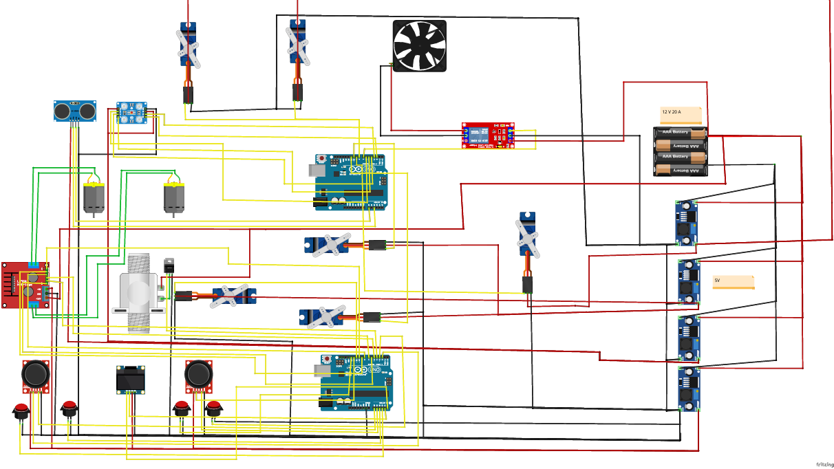
5.1 Operational Flow
- System Initialization: Home all servos, initialize I2C communication, and stabilize sensor baselines.
- Detection Phase: Poll optical sensor until a valid threshold is crossed.
- Routing Phase: Actuate gate servo to target angle engage pneumatic blower.
- Staging Phase: Await upper IR sensor interrupt actuate distributor servo.
- Combat Phase: Maintain steady-state flywheel RPM monitor HMI inputs via external interrupts.

5.2 Microcontroller Source Code
#include <Servo.h>

#define S0 2
#define S1 3
#define S2 4
#define S3 5
#define sensorOut 6

Servo sorterServo;

int redFrequency = 0;
int blueFrequency = 0;

void setup() {

pinMode(S0, OUTPUT);
pinMode(S1, OUTPUT);
pinMode(S2, OUTPUT);
pinMode(S3, OUTPUT);
pinMode(sensorOut, INPUT);

digitalWrite(S0, HIGH);
digitalWrite(S1, LOW);

sorterServo.attach(9);
sorterServo.write(90);

Serial.begin(9600);
}

void loop() {

digitalWrite(S2, LOW);
digitalWrite(S3, LOW);
redFrequency = pulseIn(sensorOut, LOW);
delay(100);

digitalWrite(S2, LOW);
digitalWrite(S3, HIGH);
blueFrequency = pulseIn(sensorOut, LOW);
delay(100);

if (redFrequency < blueFrequency & redFrequency<100 ) {
Serial.println(" - RED Detected!");
sorterServo.write(45);
delay(1000);
}
else if (blueFrequency < redFrequency & blueFrequency<100) {
Serial.println(" - BLUE Detected!");
sorterServo.write(135);
delay(1000);
}

sorterServo.write(90);
delay(500);
}

6. System Reliability and Failure Mode Mitigation
To transition the system from a theoretical prototype to a reliable electromechanical loop, several real-world engineering challenges were addressed:
- Signal Integrity and Noise: Initial testing showed the optical sensor was susceptible to ambient light pollution. A custom 3D-printed shroud was integrated to isolate the sensing environment, ensuring consistent RGB frequency readings regardless of external room lighting.
- Mechanical Tolerancing and Pressure Loss: Pneumatic transport failure (stalling) occurred due to air leakage. Tolerances between the tube's inner diameter and the projectiles were optimized, and all structural joints were sealed with silicone to maximize static pressure and maintain a consistent aerodynamic drag force.
- Electromechanical Power Droop: Successive rapid firing caused a drop in launch velocity due to the DC motors losing momentum and drawing high inrush currents. A software-enforced cooldown window was implemented in the HMI logic, allowing the flywheels to recover to their nominal RPM before the solenoid could be triggered again. Furthermore, opto-isolators and flyback diodes were installed on all inductive loads (motors and solenoids) to protect the 5V logic controller from reverse voltage spikes.
7. Conclusion
The "Cosmios" project successfully demonstrates the integration of complex mechatronic subsystems into a cohesive, highly reliable closed-loop architecture. By rigidly applying principles of kinetic energy transfer and fluid dynamics, the system processes 5g projectiles with minimal failure rates. The implementation of robust HMI control, coupled with non-blocking logic and physical fail-safes against sensor noise and voltage spikes, ensures a seamless and competitive user experience.

